Go to Performance 🡪 Advisors Home

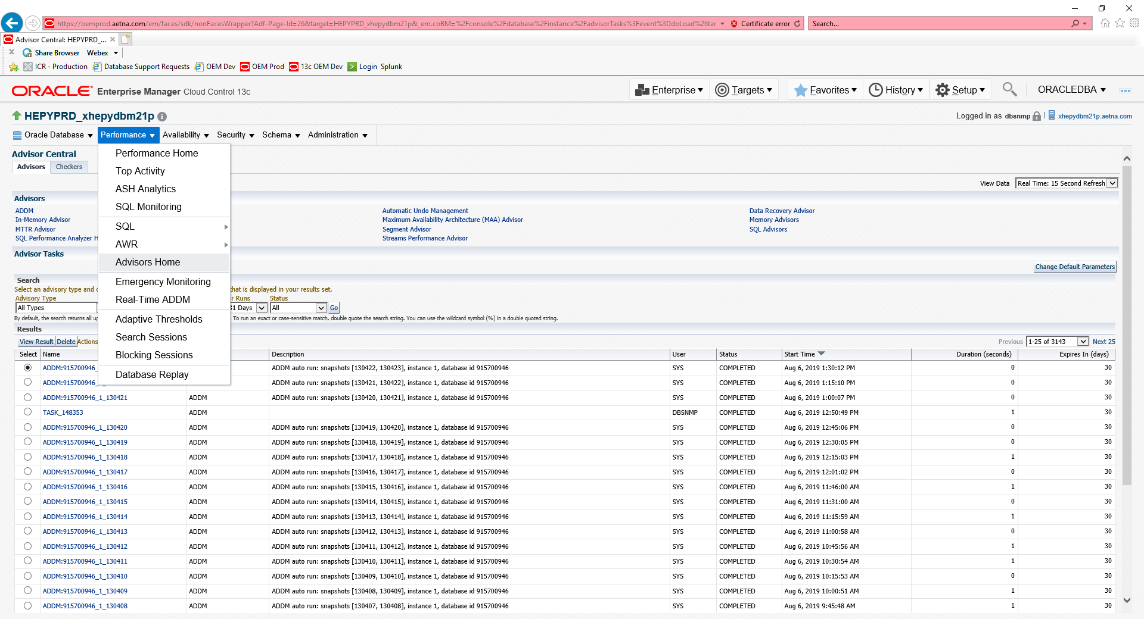

Click on ADDM name link with closes start time that you need

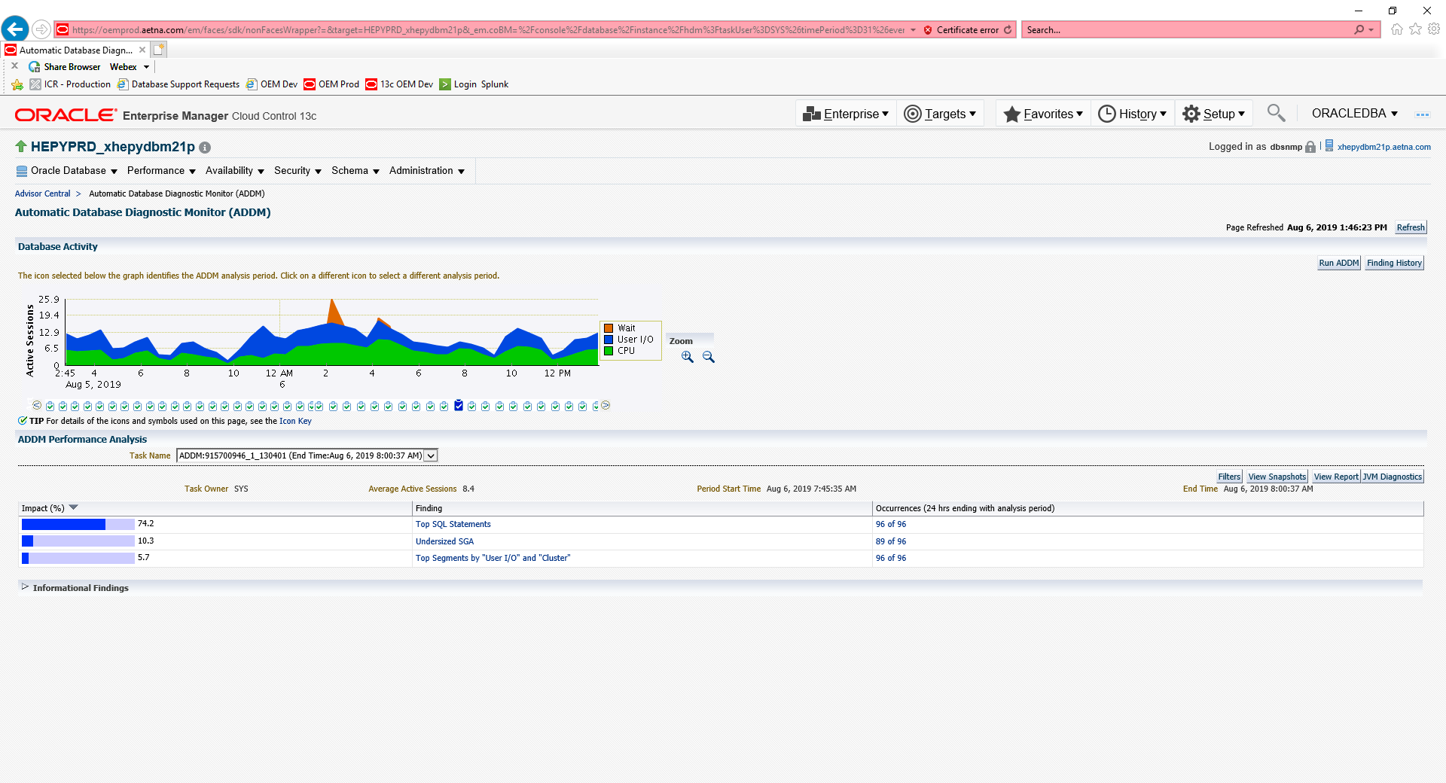

Click on Run ADDM button

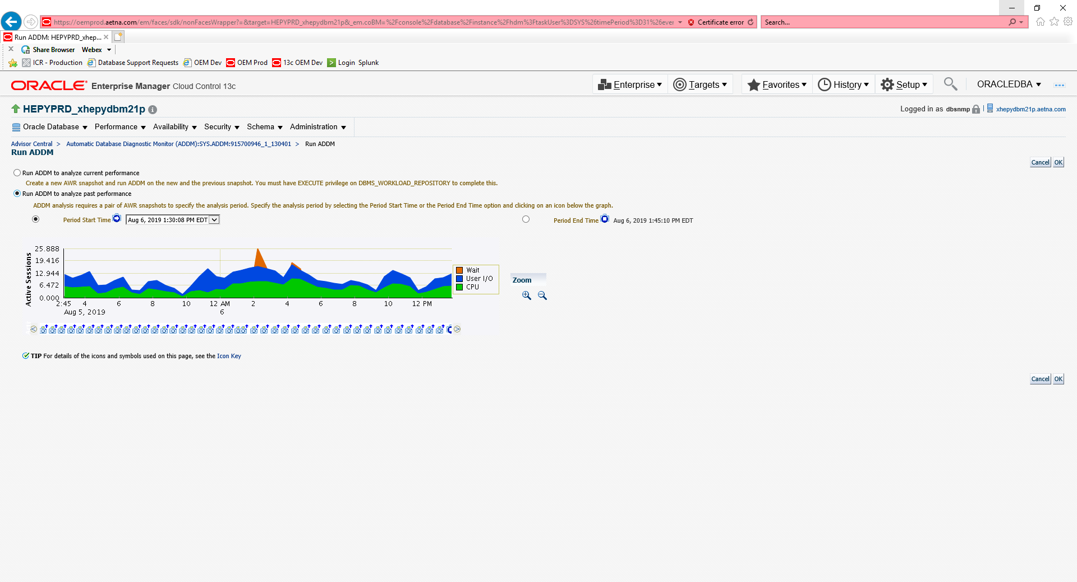

Select Run ADDM to analyze past performance radio button

Select Period Start Time Radio button and click on appropriate snapshot (time) blue ribbon square under the graph

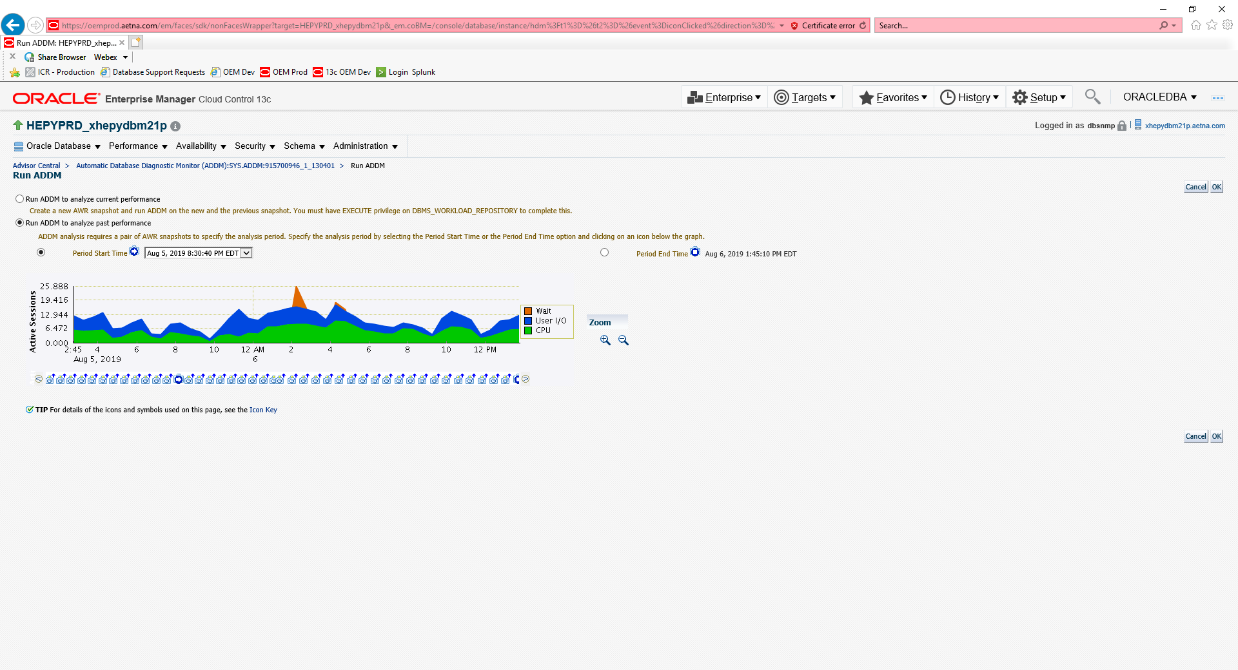

Select Period End Time Radio button and click on appropriate snapshot (time) blue ribbon square under the graph

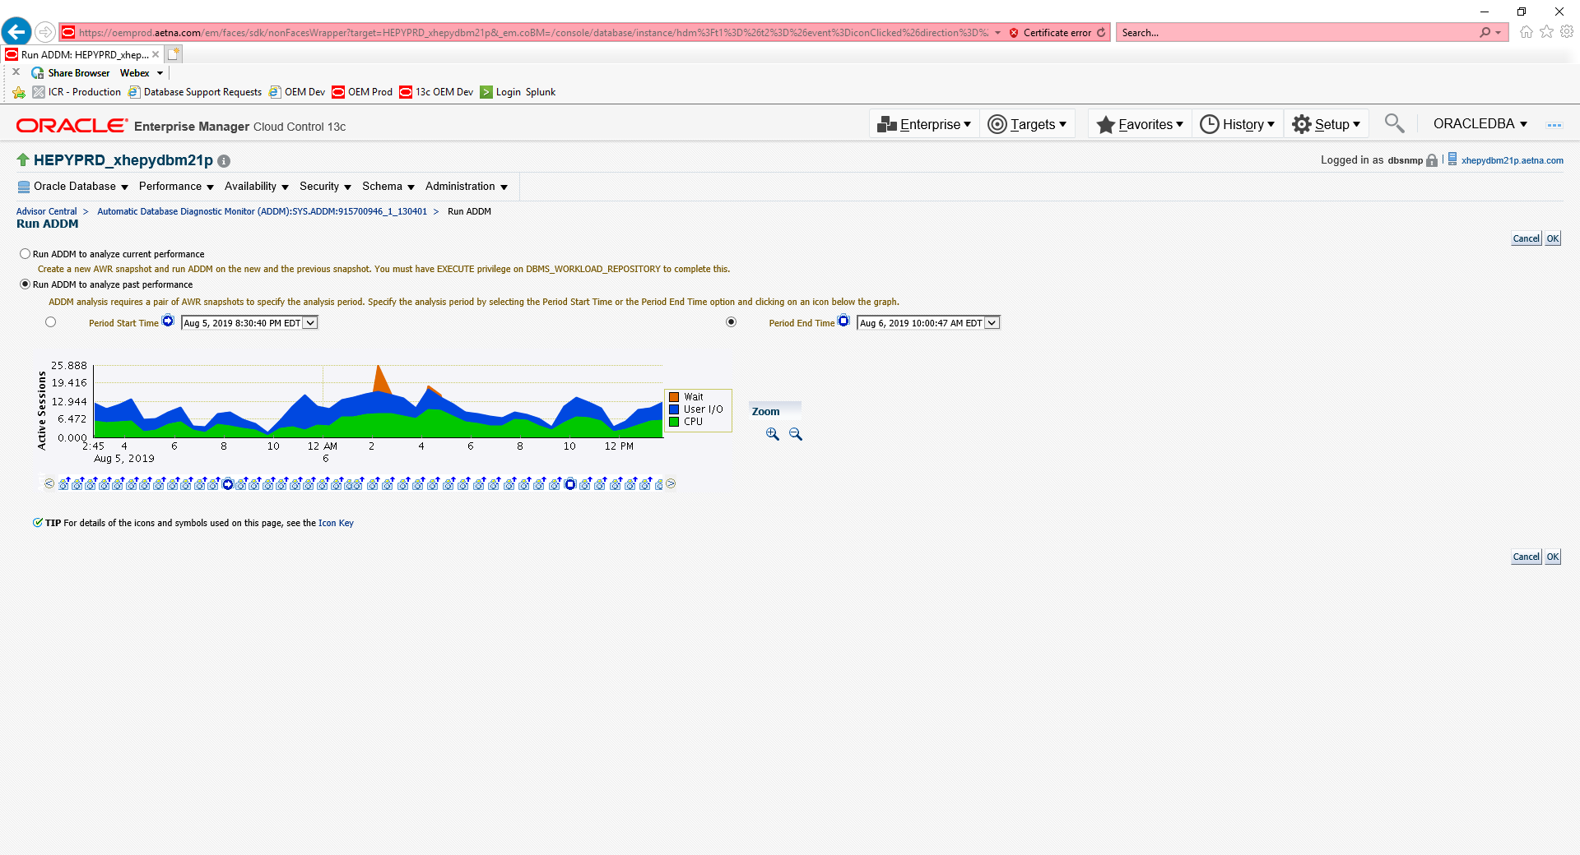

Click OK button

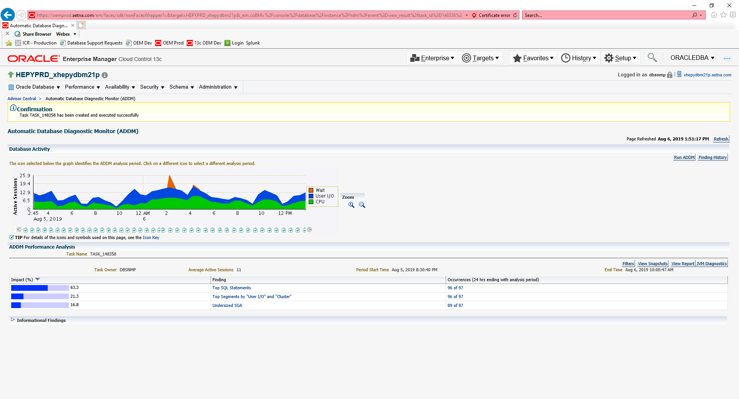

Click View Report button

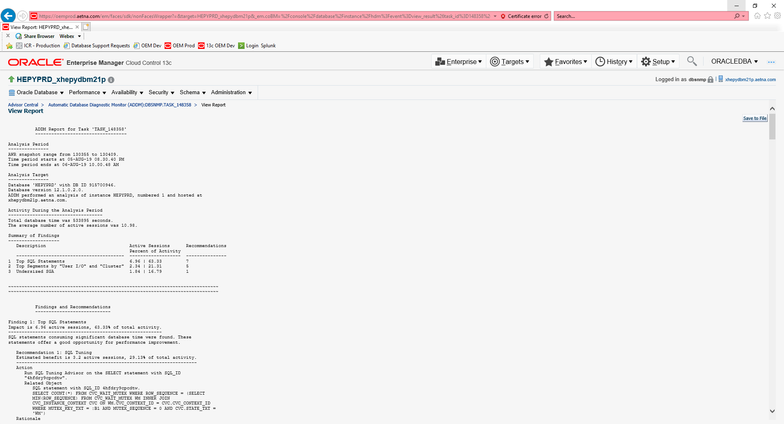

Click Save to File button